**CASE ENCLOSURE PARTS LIST**

You will need:

1. Access to a CNC machine
2. Access to 3D printer w/ ABS filament (preferably black colored filament)
3. M3-0.5 x 10mm DIN 912 Hex Drive Grade A2-70 Stainless Steel Socket Cap Screw (8 pieces)

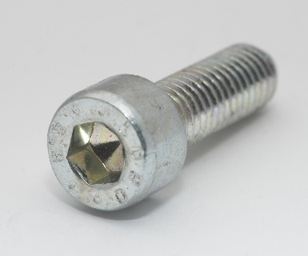

1. 3mm thick square acrylic plates (15 cm x 15 cm) (2 pieces) preferably black colored and glossy.
2. 3mm tap drill bit and a tapping drill

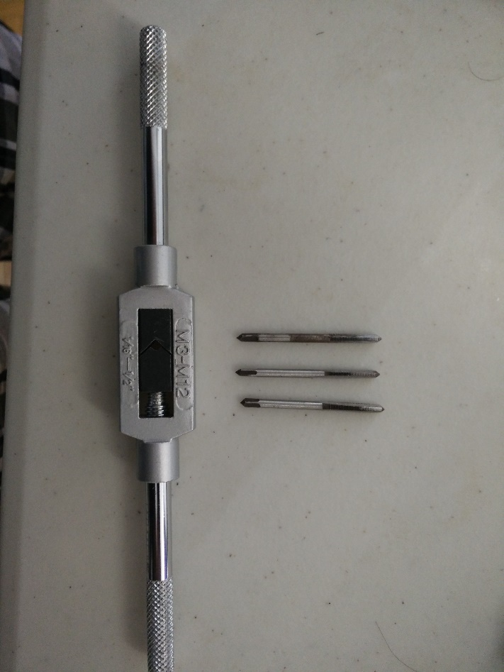

1. Allen key
2. Glue gun

CASE enclosure consists of the following parts:

1. The front plate
2. The back plate
3. The Covering

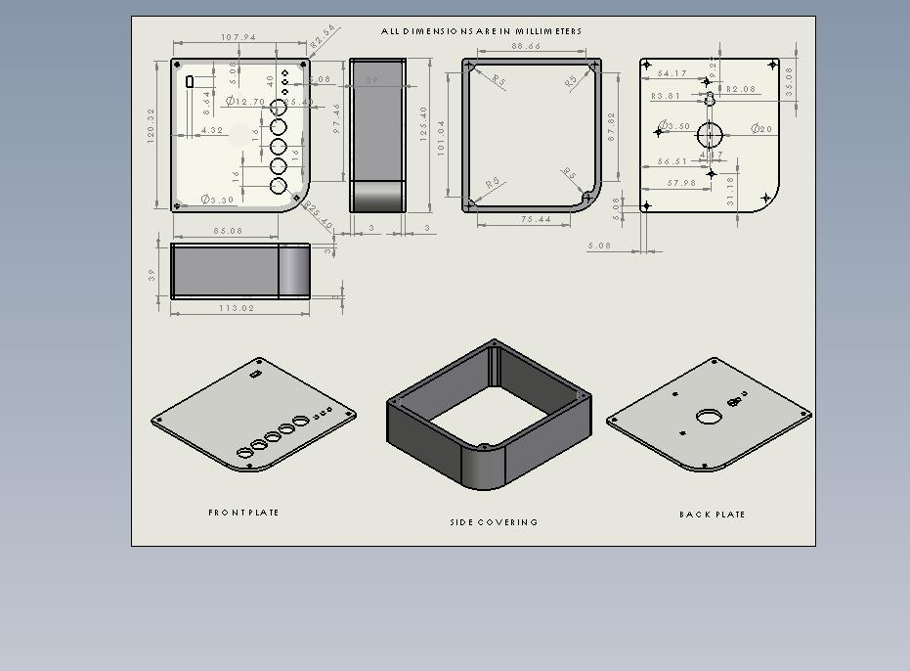

Instructions:

1. The front plate and back plate are 3mm thick acrylic plates (preferably black colored). Use the STEP files in the Case Enclosure Folder. The front_plate.STEP file back_plate.STEP file have to used to cut the acrylic plates into shape using a CNC.
2. The side_covering.STL file must be 3D printed with ABS filament.
3. Using the 3mm tapping drill bits and the hand tapping tool, carefully thread the 8 holes (4 on each side) of the side_covering.
4. Place the front panel on the side covering as shown below:

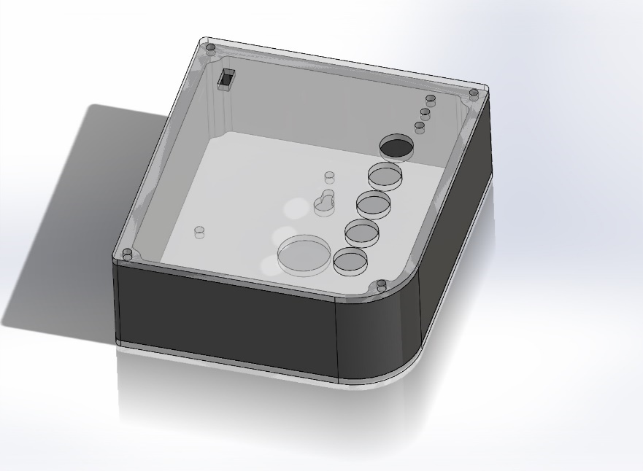

1. Place 4 screws and fix front plate onto the side covering. Make sure not to make it too tight – this can destroy the threads in the ABS plastic.
2. Fix the pushbuttons, the LEDs and switch onto the front plate as shown below. Use a glue gun where necessary. You may want to stick stickers to label the items.

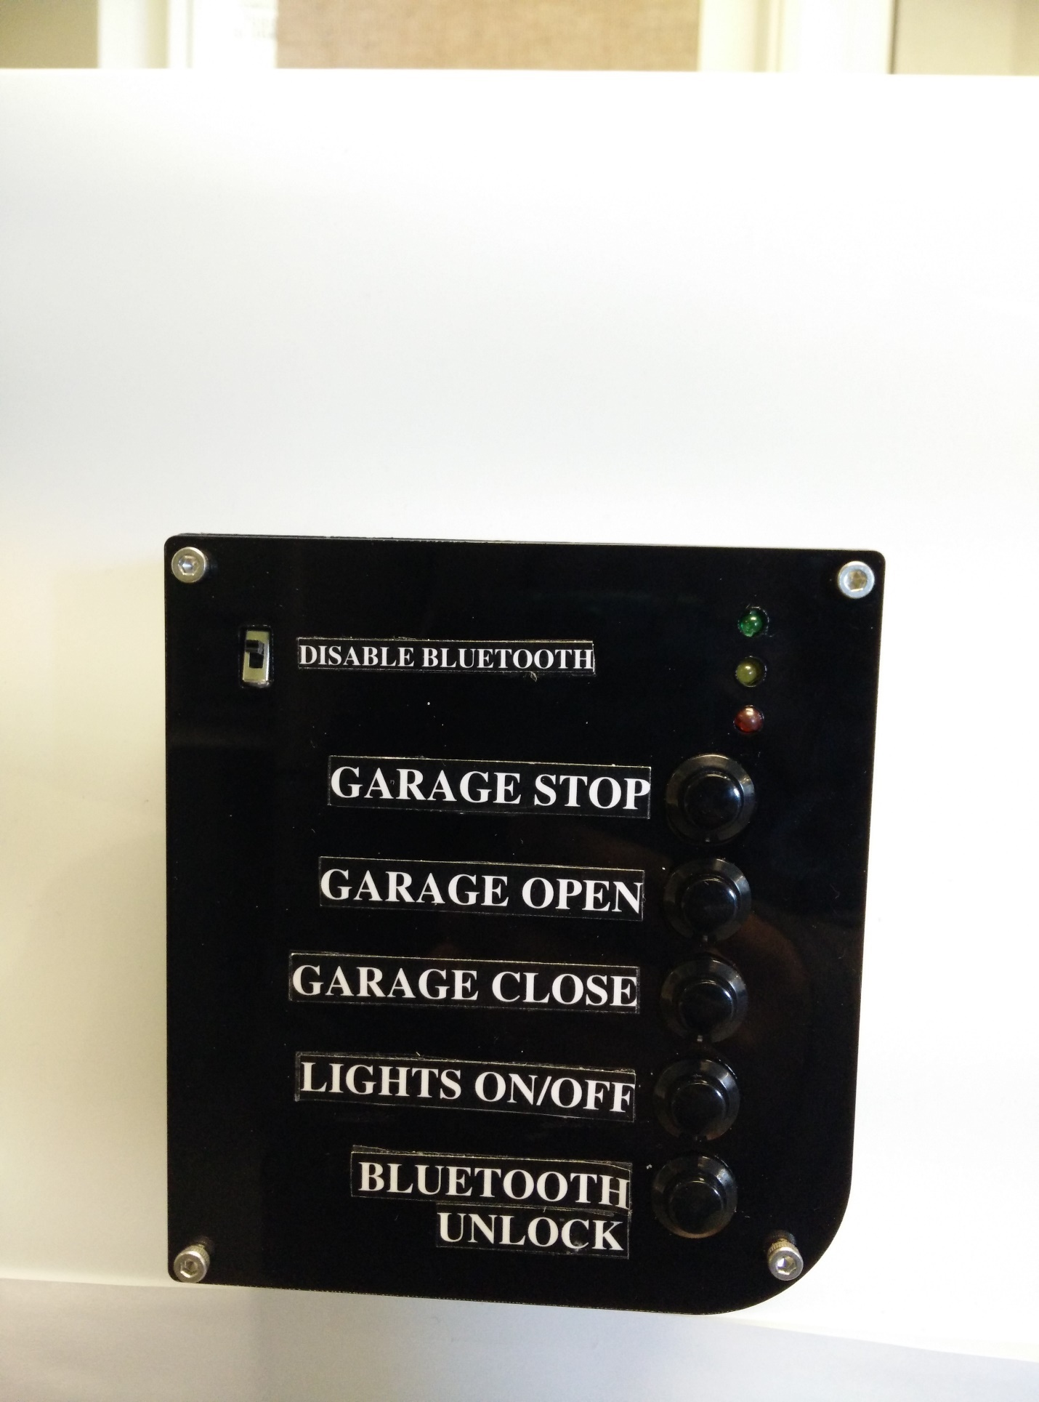

1. Solder connecting wires between the buttons, LEDs and switch onto the PCB with relays.
2. The large hole in the middle of the back plate is for wires to stick out from. These wires can connect the relays to compatible garage openers.
3. Fasten the back plate with the four remaining socket cap screws onto the side covering. Make sure you don’t tighten them too much as it can destroy the threads in the ABS plastic side covering.
4. The Gate box device can now be mounted onto a nail on a wail like a clock.